Project Report Format
- INTRODUCTION
The rapid growth of electric vehicles (EVs) is transforming transportation systems worldwide, including India. Understanding EV adoption patterns, charging behaviour, driving range performance, and infrastructure expansion is essential for policymakers, researchers, and industry stakeholders.
This website presents an integrated analysis of electric vehicle data collected from multiple sources across India and global markets. By combining diverse datasets and visualising them through interactive dashboards and data stories, the platform enables users to explore trends, compare performance indicators, and gain insights into the evolving EV ecosystem.
  - Project Overview
This EV analytics website integrates four different datasets related to electric vehicle usage, charging behaviour, driving range, and infrastructure development. The platform processes and analyses the data to generate meaningful insights, which are presented through interactive Tableau dashboards and narrative data stories.
The website provides users with:
- Visual analysis of EV charging patterns
- Comparison of driving range performance
- Trends in EV adoption across regions
- Interactive dashboards for exploration
- Story-based visual explanations
By presenting complex EV data in an accessible and visual format, the platform supports better understanding of electric mobility trends and technological progress.
  - Purpose
The purpose of this EV analytics website is to provide a comprehensive, data-driven understanding of electric vehicle ecosystems in India and globally. The platform aims to:
- Analyse EV adoption and usage trends
- Examine charging behaviour and infrastructure growth
- Compare driving range performance across vehicles
- Integrate multiple EV datasets into a unified view
- Present insights through interactive dashboards and stories
- Support research, policy awareness, and public understanding
Ultimately, the website serves as an interactive information resource that helps users explore and interpret electric vehicle data through visual analytics.

- IDEATION PHASE
The ideation phase focuses on identifying the core problem, understanding user needs, and generating solutions for presenting electric vehicle data in a meaningful and accessible way. Since EV datasets are often scattered, complex, and difficult to interpret, the project aims to transform raw data into interactive visual insights through a web-based analytics platform.
  - Problem Statement
Electric vehicle data related to charging behaviour, driving range, infrastructure availability, and adoption trends is distributed across multiple sources and formats. This makes it difficult for users such as researchers, policymakers, and the general public to analyse and interpret EV trends effectively.
There is a need for an integrated, interactive platform that consolidates EV datasets and presents them through clear visual analytics and data stories, enabling users to explore insights about electric mobility in an intuitive and accessible manner.
  - Empathy Map Canvas
Target Users:
- Researchers and students
- Policymakers and planners
- EV enthusiasts
- General public
Says:
- “I want to understand EV trends.”
- “How is EV adoption growing?”
- “Which brands have better range?”
- “Are charging stations increasing?”
Thinks:
- EV data is scattered and confusing
- Hard to compare vehicles and regions
- Need reliable visual insights
- Want simplified dashboards
Does:
- Searches EV statistics online
- Reads reports and articles
- Uses dashboards occasionally
- Compares vehicle specs
Feels:
- Overwhelmed by raw data
- Curious about EV growth
- Interested in sustainability
- Needs clear information
Needs:
- Centralized EV data platform
- Interactive visual dashboards
- Comparative analysis tools
- Story-based insights

  - Brainstorming
During brainstorming, multiple ideas were explored to address the identified problem of fragmented EV data and poor accessibility of insights.
Key Ideas Generated:
- Integrate multiple EV datasets into one platform
- Create interactive dashboards using Tableau
- Develop story-based visual analytics
- Provide comparisons across brands and regions
- Visualize charging infrastructure growth
- Show EV adoption trends over time
- Design a user-friendly web interface
- Enable exploratory data interaction
Selected Solution:
Develop an EV analytics website that integrates datasets and presents insights through interactive dashboards and data stories, allowing users to explore electric vehicle trends, charging behaviour, and infrastructure growth in an intuitive visual format.

- REQUIREMENT ANALYSIS
This phase defines how users interact with the EV analytics website, the required system features, data flow, and technologies used to implement the platform.
  - Customer Journey map
Awareness:
User visits the EV analytics website to explore electric vehicle trends.
Exploration:
User navigates through sections such as Dashboard and Story to view EV insights.
Interaction:
User interacts with Tableau visualizations to analyse charging patterns, range, and adoption data.
Understanding:
User interprets visual trends and comparisons across regions, vehicles, and infrastructure.
Outcome:
User gains clear understanding of EV ecosystem trends and insights.
  - Solution Requirement
Functional Requirements:
- Display EV dashboard and story visualizations
- Integrate multiple EV datasets via Tableau
- Provide interactive charts and filters
- Enable navigation between sections
- Present EV insights visually
Non-Functional Requirements:
- Responsive web design
- Fast visualization loading
- Public accessibility
- Cross-browser compatibility
- User-friendly interface
  - Data Flow Diagram
Level 0 (Context):
Data Sources → EV Analytics Platform → Users
Level 1:
EV Datasets → Data Processing & Analysis → Tableau Dashboards/Story → Website → Users
Explanation:
Multiple EV datasets are analysed in Tableau. The generated dashboards and stories are embedded into the website, allowing users to interact with visual insights.
  - Technology Stack
Data Visualization: Tableau Public
Frontend: HTML, CSS, Bootstrap
Visualization Embed: Tableau JavaScript API
Design Template: Bootslander Bootstrap Template
Data Sources: EV datasets (India & Global)
Platform: Web Browser

- PROJECT DESIGN
The project design phase defines how the identified problem is addressed through a structured solution. The EV analytics website is designed to integrate multiple electric vehicle datasets and present insights through interactive dashboards and visual stories in a user-friendly web interface.
  - Problem Solution Fit
Problem:
Electric vehicle data is scattered across multiple sources and formats, making it difficult for users to analyse EV charging behaviour, driving range, adoption trends, and infrastructure growth.
User Needs:
- Centralized EV data access
- Clear visual insights
- Interactive exploration
- Easy comparison of trends
Solution Fit:
The EV analytics website consolidates datasets and presents them through Tableau dashboards and stories embedded in a responsive web interface. This directly addresses the need for accessible, visual, and integrated EV analytics.
  - Proposed Solution
The proposed solution is an interactive EV analytics website that integrates multiple datasets and delivers insights through embedded Tableau visualizations.
Key Features:
- Integrated EV datasets (India & global)
- Interactive dashboard (Desktop section)
- Narrative data story (Story section)
- User-friendly navigation interface
- Visual analysis of EV trends
User Flow:
User visits website → selects Dashboard or Story → interacts with visualizations → explores EV insights.
  - Solution Architecture
Architecture Type: Web-based Data Visualization Architecture
Components:
- Data Sources
Multiple EV datasets (charging, range, adoption, infrastructure)
- Data Analysis Layer
Data processed and visualized in Tableau
- Visualization Layer
Tableau Dashboards and Story
- Web Interface Layer
HTML + Bootstrap website
- User Layer
End users accessing via browser
Flow:
EV Data → Tableau Analysis → Dashboard/Story → Website Embed → User Interaction

- PROJECT PLANNING & SCHEDULING
This phase outlines how the EV analytics website project was planned, including the sequence of activities required to collect data, create visualizations, develop the website, and deploy the final analytics platform. Proper planning ensured systematic integration of datasets, dashboard development, and web implementation.
  - Project Planning
The project was planned in structured stages to ensure smooth development of the EV analytics platform.
Phase 1 – Problem Identification & Research
- Study electric vehicle domain and trends
- Identify need for EV analytics platform
- Define project objectives
Phase 2 – Data Collection
- Gather EV datasets from multiple sources
- Validate and organise datasets
- Prepare data for analysis
Phase 3 – Data Analysis & Visualization
- Import datasets into Tableau
- Create dashboards for EV insights
- Develop story-based visualizations
Phase 4 – Website Development
- Customize Bootstrap template
- Design navigation and layout
- Embed Tableau dashboard and story
Phase 5 – Testing & Refinement
- Check visualization loading
- Test navigation and responsiveness
- Improve layout and usability
Phase 6 – Deployment
- Publish Tableau visuals
- Host website files
- Final verification

- FUNCTIONAL AND PERFORMANCE TESTING
This phase evaluates whether the EV analytics website functions correctly and performs efficiently when users interact with dashboards and visual stories. Testing ensures that all website sections, navigation elements, and embedded Tableau visualizations operate reliably across devices and browsers.
  - Performance Testing
Performance testing was conducted to verify the responsiveness, loading speed, and stability of the EV analytics website and its embedded visualizations.
Parameters Tested:
- Dashboard loading time
- Story loading time
- Navigation responsiveness
- Visualization interaction speed
- Cross-device performance
- Browser compatibility
Test Observations:
- Tableau dashboards loaded successfully within acceptable time.
- Story visualizations rendered correctly without errors.
- Navigation between Home, Desktop, and Story sections was smooth.
- Visual interactions (filters, hover, selection) responded correctly.
- Website displayed properly on desktop and mobile screens.
- No major performance issues observed.
Result:
The EV analytics website met performance expectations. Embedded dashboards and stories were accessible, responsive, and stable, providing a smooth user experience for exploring EV data insights.

- RESULTS
The Electric Vehicle Charge and Range Analysis Visualization Tool was successfully developed and deployed as an interactive web-based platform integrating Tableau dashboards and stories. The system consolidates multiple EV datasets and presents insights related to charging behaviour, driving range, adoption trends, and infrastructure growth in a clear visual format.
Users can access interactive dashboards and stories directly from the website interface. The embedded Tableau visualizations allow filtering, exploration, and comparison of EV parameters across regions and time periods. The platform effectively transforms complex EV datasets into understandable visual insights, supporting data-driven understanding of electric mobility patterns
Overall, the implemented system meets the project objectives of EV data integration, visualization, and web-based presentation.
  - Output Screenshots
Home Page
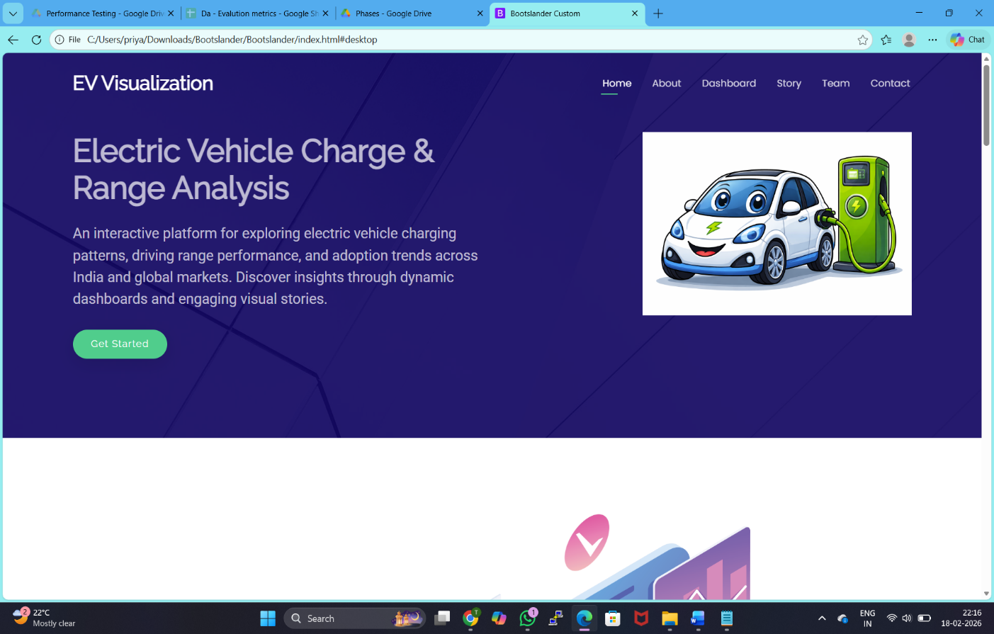
About
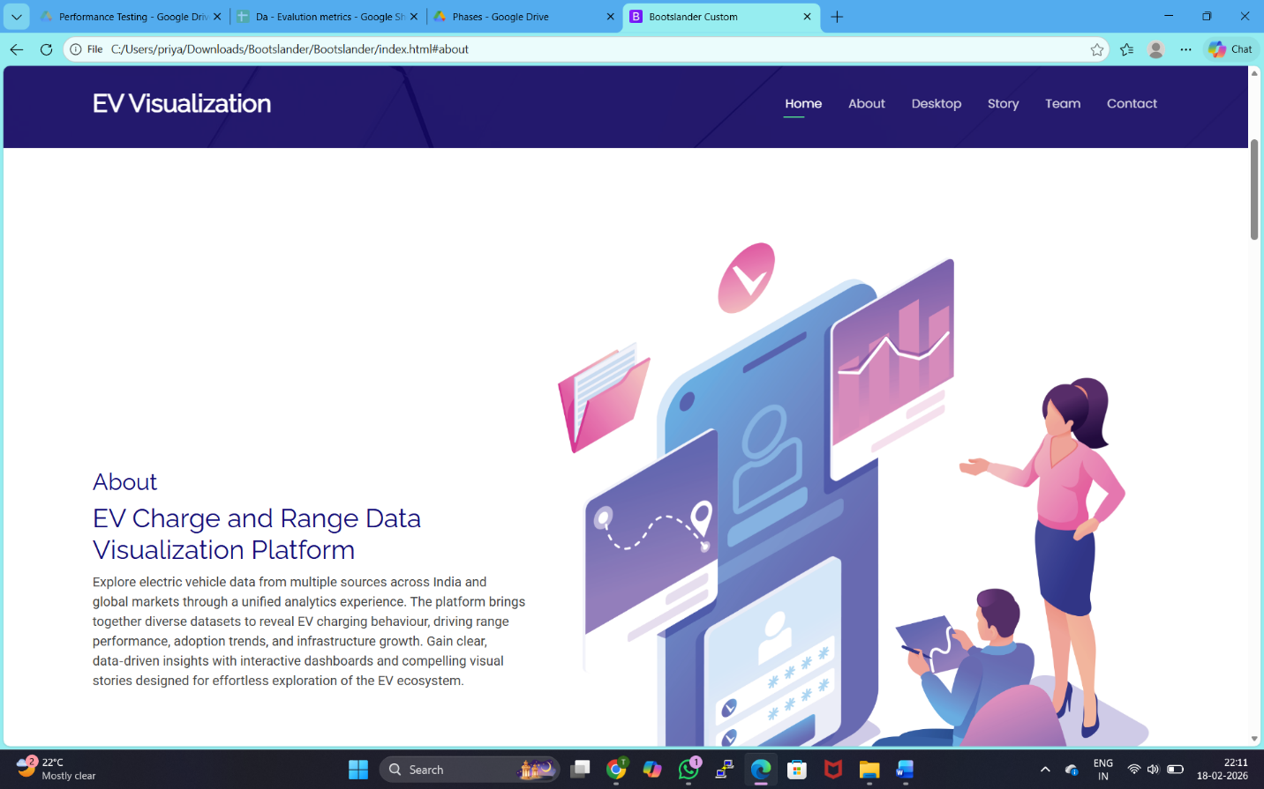
Dashboard
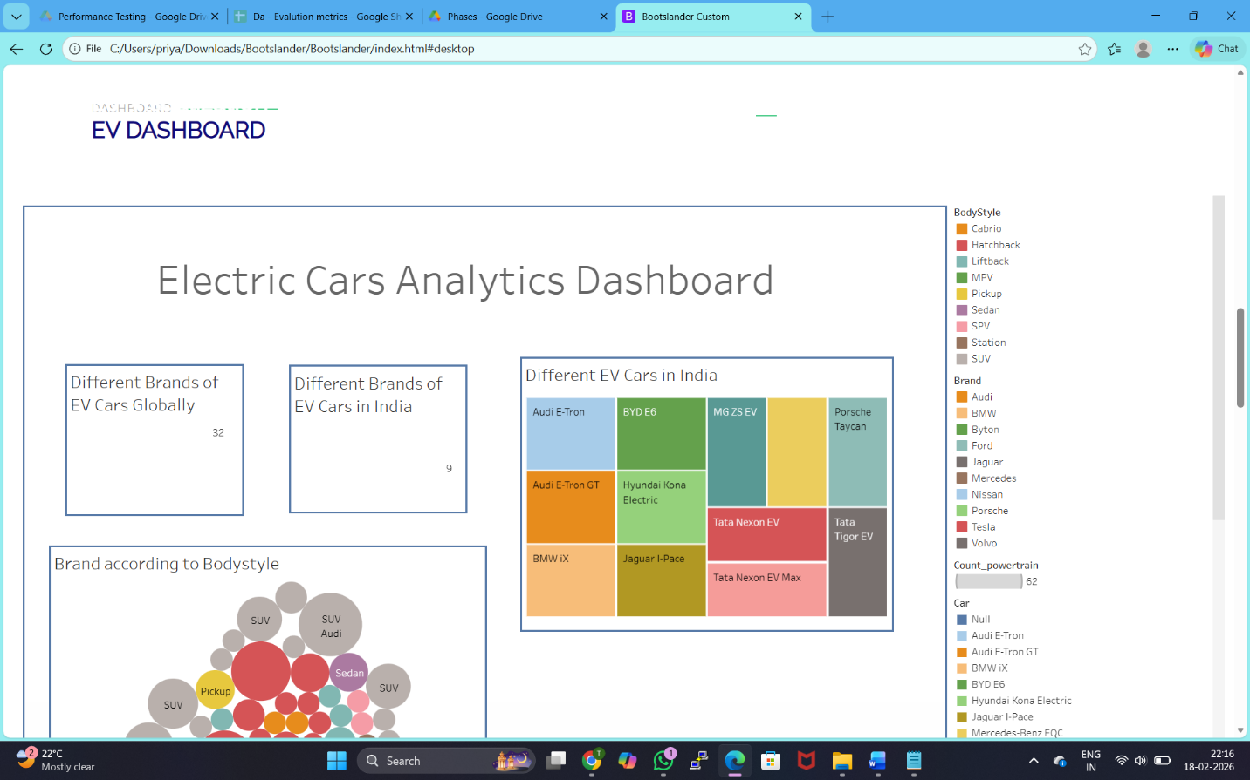
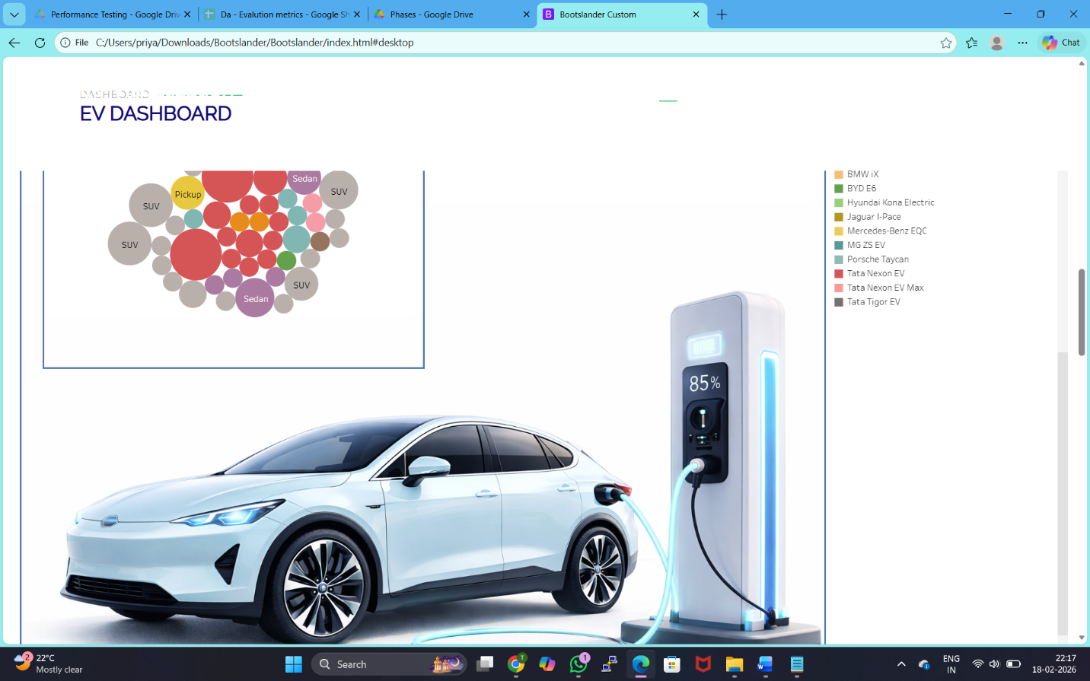
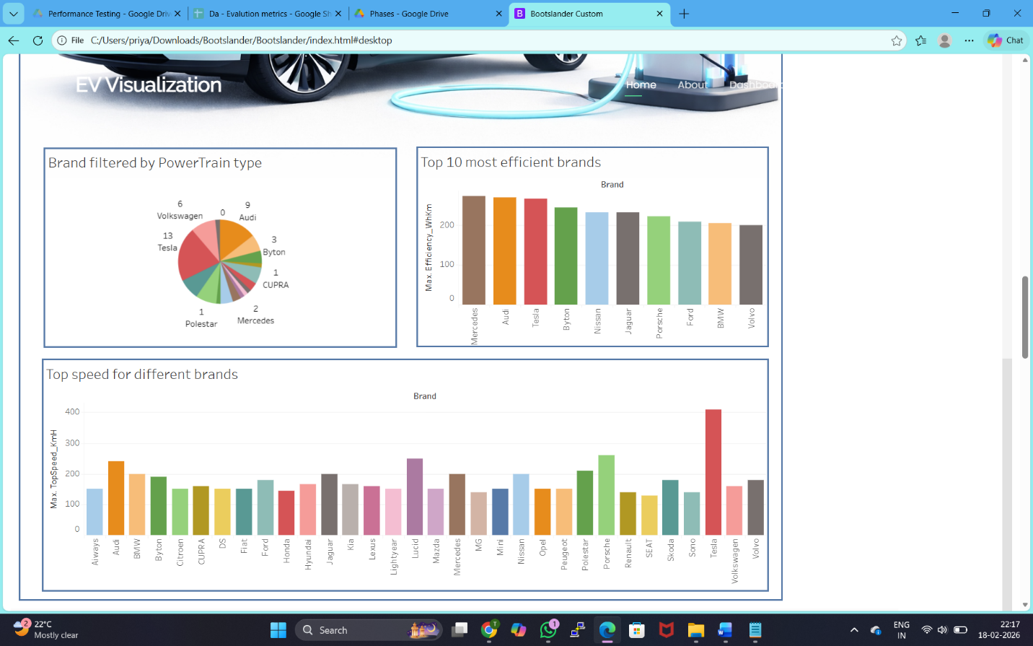
Story
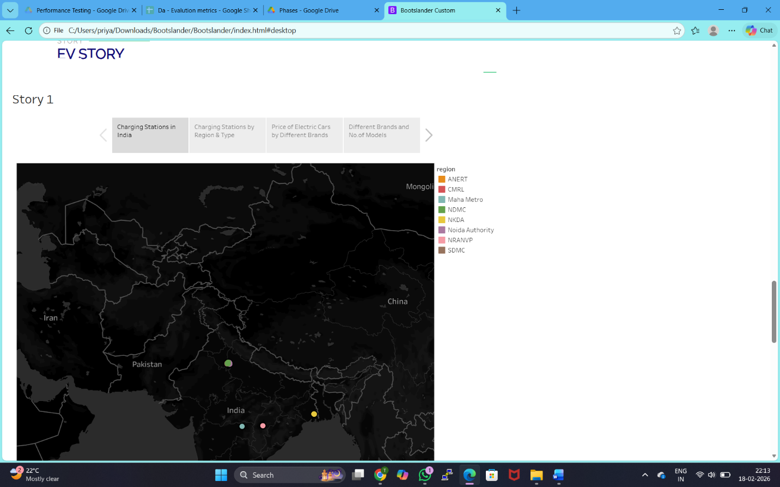
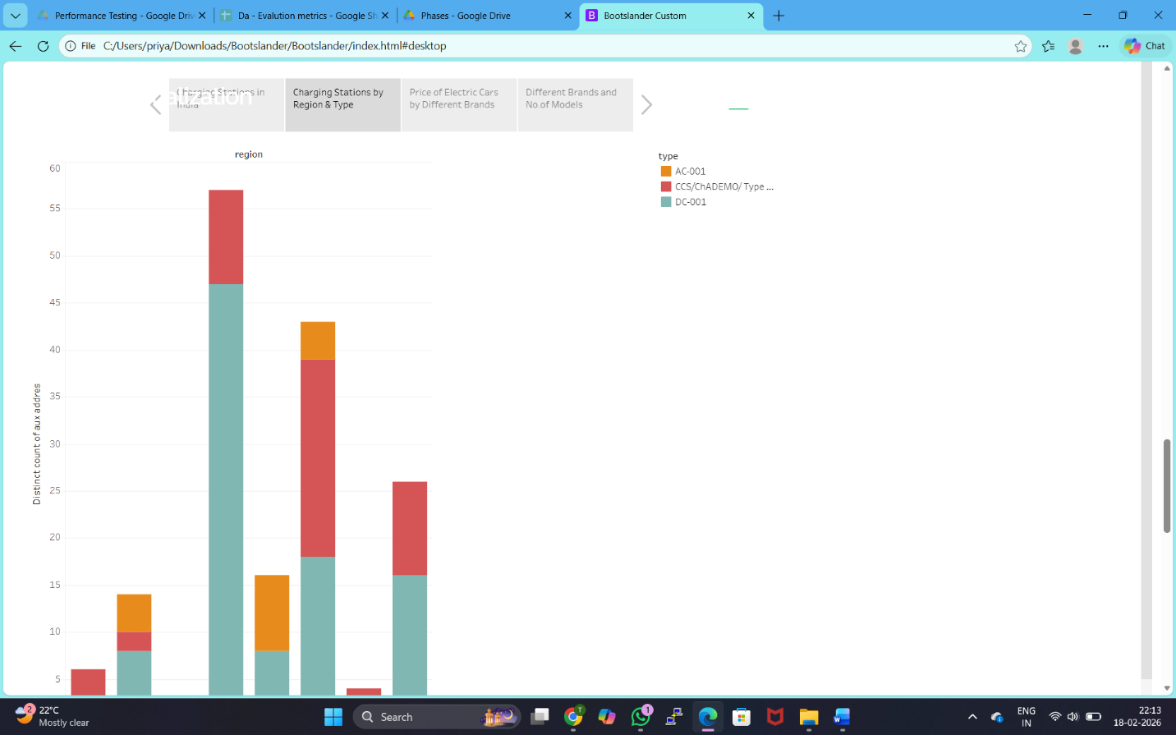
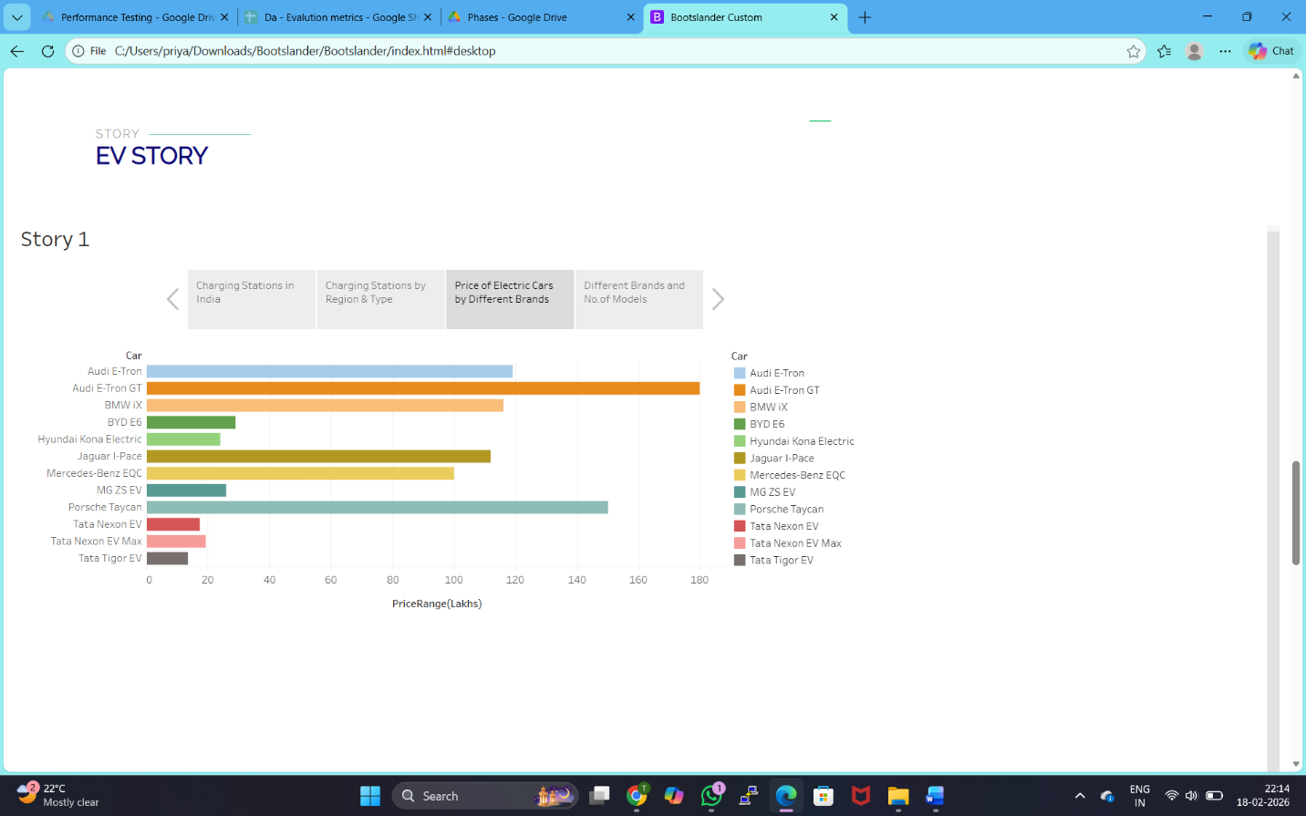
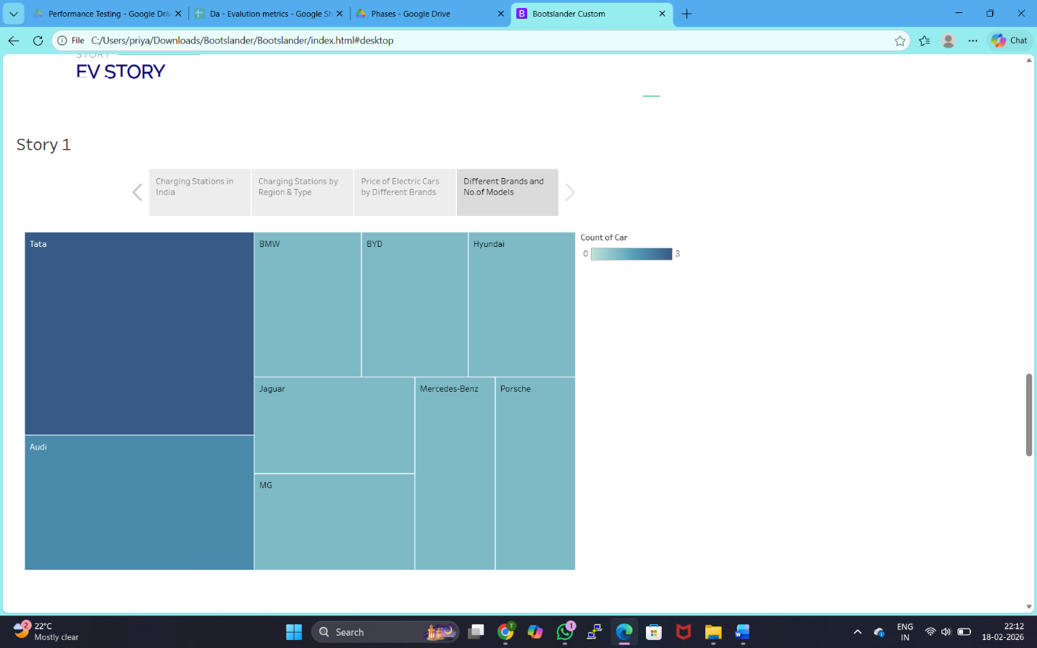
Team


Contact

- ADVANTAGES & DISADVANTAGES
Advantages
- Integrates multiple EV datasets into a single platform
- Provides clear visualization of charging and range patterns
- Interactive dashboards improve data exploration
- Web-based access without installing software
- Supports understanding of EV adoption trends and infrastructure growth
- Scalable for adding new datasets and analytics
Disadvantages
- Depends on availability and quality of EV datasets
- Static data (not real-time updates)
- Limited user interaction beyond visualization
- Requires internet connection to load Tableau visuals
- Not connected to live EV charging networks

- CONCLUSION
The Electric Vehicle Charge and Range Analysis Visualization Tool successfully demonstrates how multi-source EV datasets can be integrated and visualized through an interactive web platform. By embedding Tableau dashboards and stories into a responsive website, the system enables users to explore electric vehicle charging behaviour, driving range performance, and adoption trends in an intuitive and visually engaging manner.
The project meets its objective of transforming complex EV data into meaningful insights that support understanding of electric mobility ecosystems. The visualization-driven approach improves accessibility of EV analytics for students, researchers, and decision-makers.
Overall, the developed platform serves as an effective prototype for EV data visualization and analysis. With future enhancements such as real-time data integration, predictive analytics, and expanded datasets, the system can evolve into a comprehensive EV analytics and decision-support platform.

- FUTURE SCOPE
The Electric Vehicle Charge and Range Analysis Visualization Tool can be further enhanced to provide deeper analytics, real-time insights, and broader EV ecosystem coverage. Future improvements can expand the platform from a static visualization website into a comprehensive EV analytics and decision-support system.
The following enhancements are proposed for future development:
- Real-time Data Integration: Connect the platform with live EV charging station and vehicle telemetry data to provide up-to-date charging behaviour and infrastructure status.
- Predictive Analytics: Apply machine learning models to forecast EV adoption trends, charging demand, and range performance under different conditions.
- Geospatial Visualization: Integrate interactive maps to display charging station distribution, regional EV density, and infrastructure gaps.
- User Interaction Features: Allow users to upload datasets, customize dashboards, and generate personalized EV analysis reports.
- Mobile Compatibility: Develop a mobile-friendly or app-based version for on-the-go access to EV insights.
- Expanded Dataset Coverage: Incorporate global EV markets, battery performance data, and policy/incentive datasets for comprehensive analysis.
- Decision-Support Modules: Provide recommendations for optimal charging infrastructure placement and EV usage planning based on data insights.
With these enhancements, the system can evolve into a scalable EV intelligence platform supporting researchers, policymakers, and industry stakeholders in advancing electric mobility adoption.

11. APPENDIX
Source Code(if any)
The project source code consists of the website interface developed using HTML, CSS, Bootstrap, and embedded Tableau visualizations. The code integrates interactive dashboards and story visualizations for analysing electric vehicle charging behaviour, range performance, and adoption trends.
Key components of the source code include:
- Landing page and navigation interface
- Dashboard embedding (Tableau Public integration)
- Story visualization embedding
- Responsive layout using Bootstrap
- Custom styling and hero section design

Dataset Link
https://drive.google.com/drive/folders/1wI4-AP7YRj8iiGJKFayLSeAccmFiD_nl?usp=drive_link
GitHub & Project Demo Link
GitHub Link
https://github.com/rrahul226/Visualization-Tool-for-Electric-Vehicle-Charge-and-Range-Analysis
Project Demo Link
https://drive.google.com/file/d/1-Ln5c6RNBCTh5QQd-iEjFIF8m9Mkuopa/view?usp=drive_link
Desktop Public Link
https://public.tableau.com/app/profile/tanderi.vishnu.priya/viz/Book1_2_17713369493400/Dashboard1?publish=yes
Story Public Link
https://public.tableau.com/app/profile/tanderi.vishnu.priya/viz/Book1_17713366067290/Story1?publish=yes&showOnboarding=true

